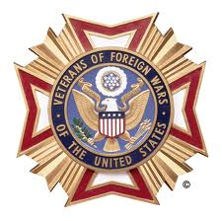
Dear Business Owner,
The VFW will be holding its 1st Annual Veterans Day Classic Golf Tournament on 11/10/19 at Grand Ridge Golf Course @ 8:00 am. Our theme this year is “Show Your Colors”, and we’re looking for your support.
The VFW has been doing some great things in our community. Besides assisting local veterans in need, the VFW provides programs such as; Teacher of the Year, First Responder of the Year, Police Officer of the Year, Boy Scout of the Year, Patriots Pen for middle school and Voice of Democracy scholarships for High School students.
It is our mission to be fraternal, patriotic, historical, charitable, and educational: to preserve and strengthen comradeship among its members; to assist worthy comrades; to perpetuate the memory and history of our dead; and to assist their widows and orphans. In order to meet our mission and provide services in our community, we rely on the generosity of individuals and businesses for support. Without the assistance of community-minded individuals just like you, we would not be able to serve those in our community each year.
We ask that you make a commitment and support our 1st Annual Veterans Day Classic Golf Tournament by sponsoring a team, sponsoring a hole, donating a prize, or just a cash donation. Your generosity will make a difference in our community by allowing us to continue in our work.
We have enclosed the sponsor information and a return envelope for your convenience. Remember that every donation makes a difference, regardless of size.
Thank you in advance for your support!

Sincerely,
Bobby Lovergne, Commander Post 3750 Monty Parr, Senior Vice Commander Post 3750
(504) 251-5628 (504) 912-8746

